
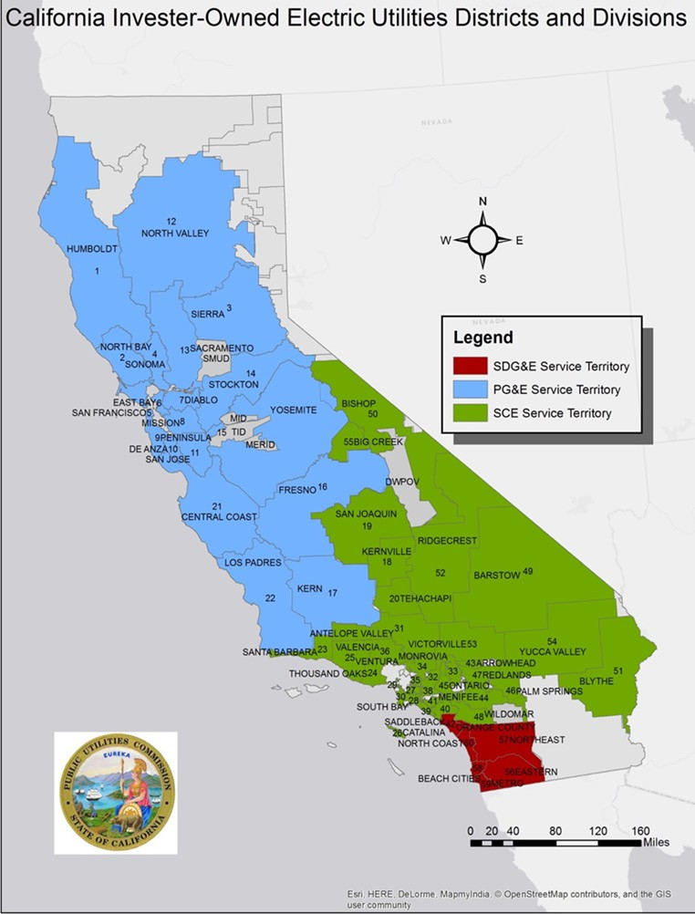
Review

of California Electric Utility Reliability 2006-2015
1





- Annual Reporting by Electric Utility
Using National Reporting Standards
IEEE 1366-2012 , first adopted by electric industry in mid-2000s






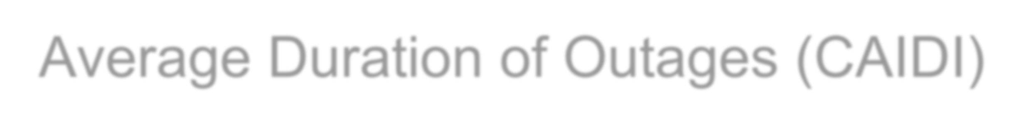

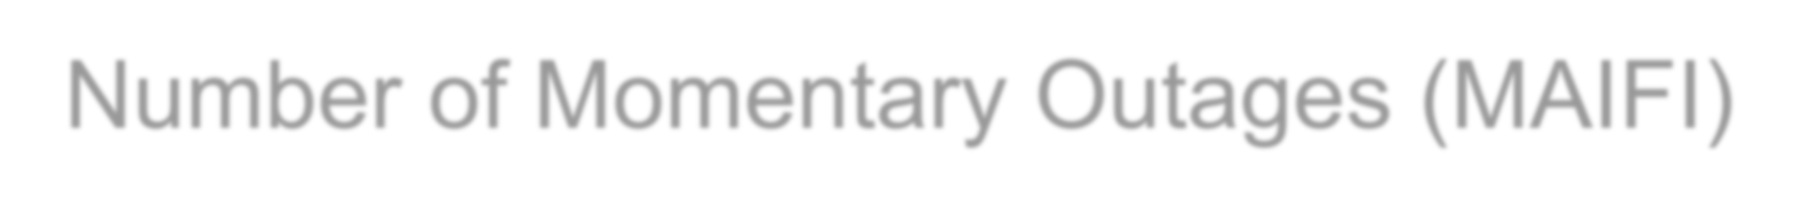
- Duration of Outages (SAIDI)
- Frequency of Outages (SAIFI)
- Average Duration of Outages (CAIDI)
- Number of Momentary Outages (MAIFI)
2

IOU Systemwide Historic Trends

600.0
Systemwide Annual SAIDI

2011 Southwest Blackout

500.0

PG&E SAIDI 10 year moving average


400.0

SCE SAIDI 10 year moving average

300.0
SDG&E SAIDI 10 year moving average



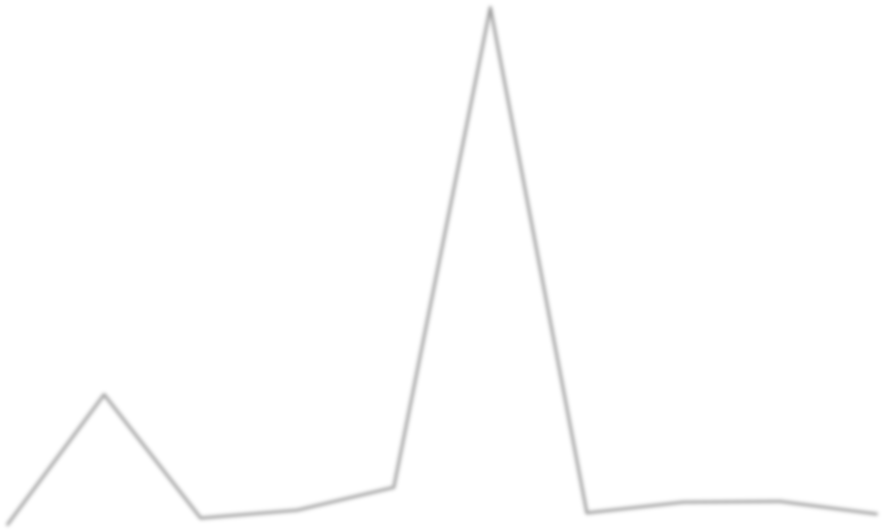
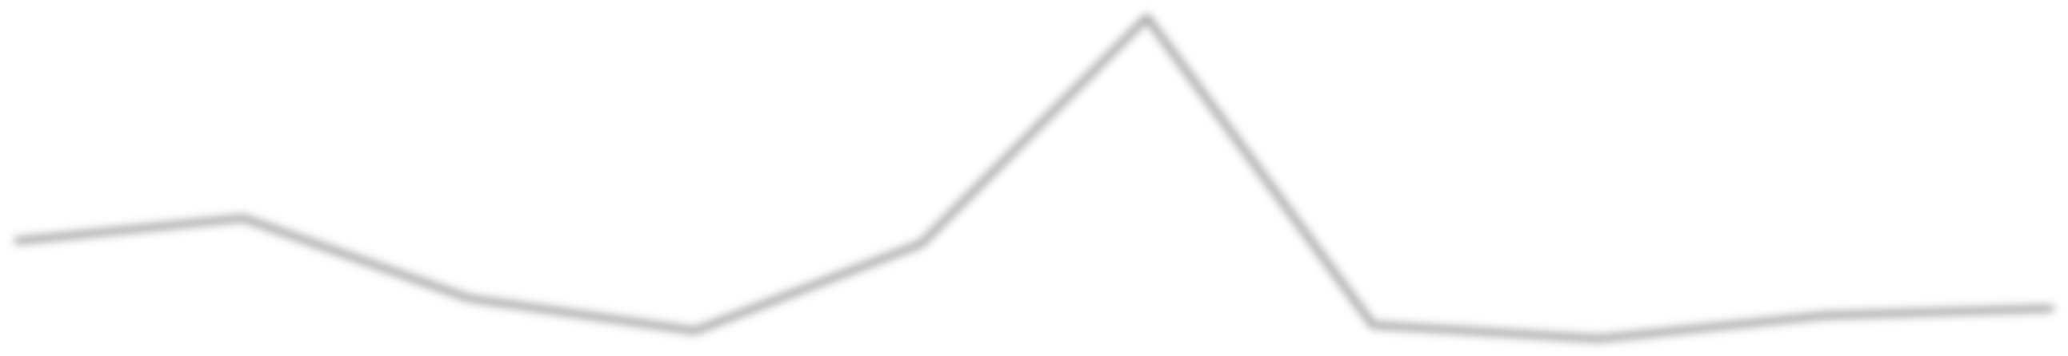
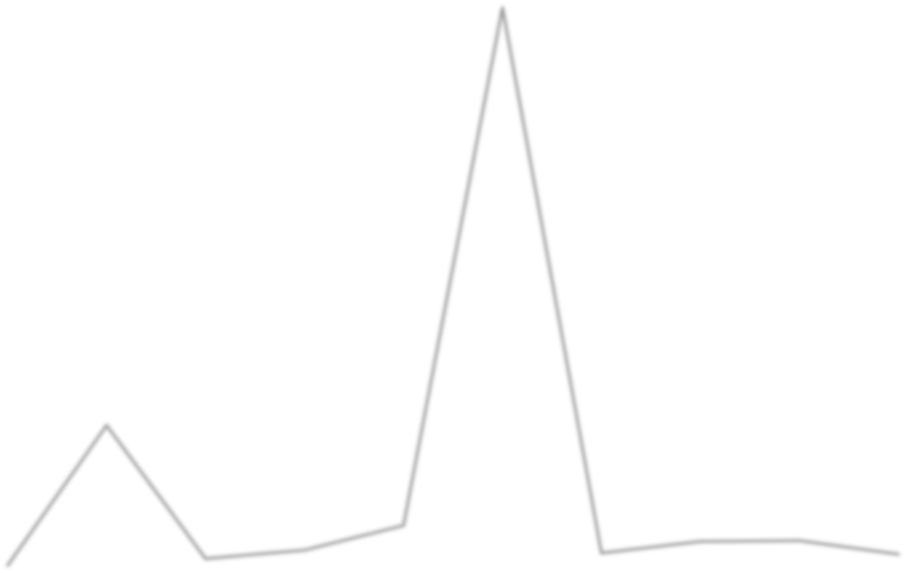

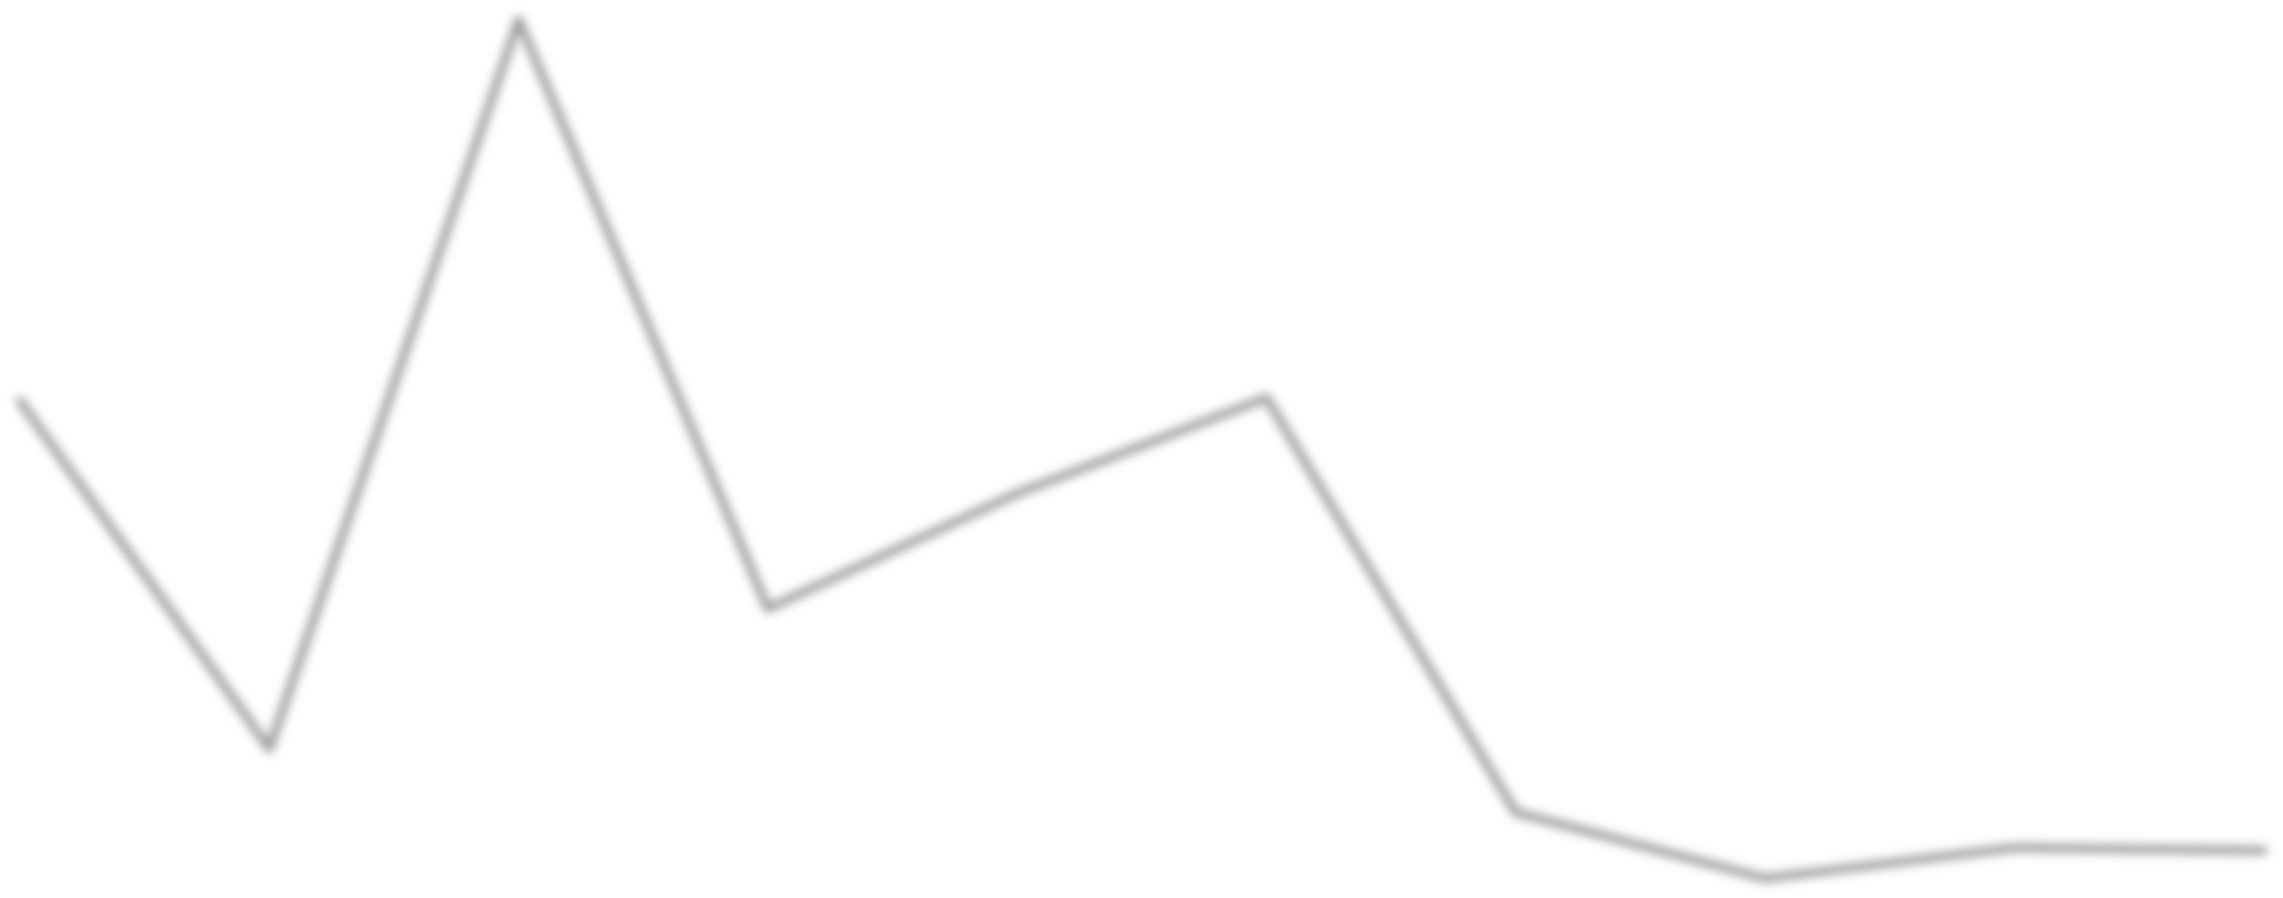
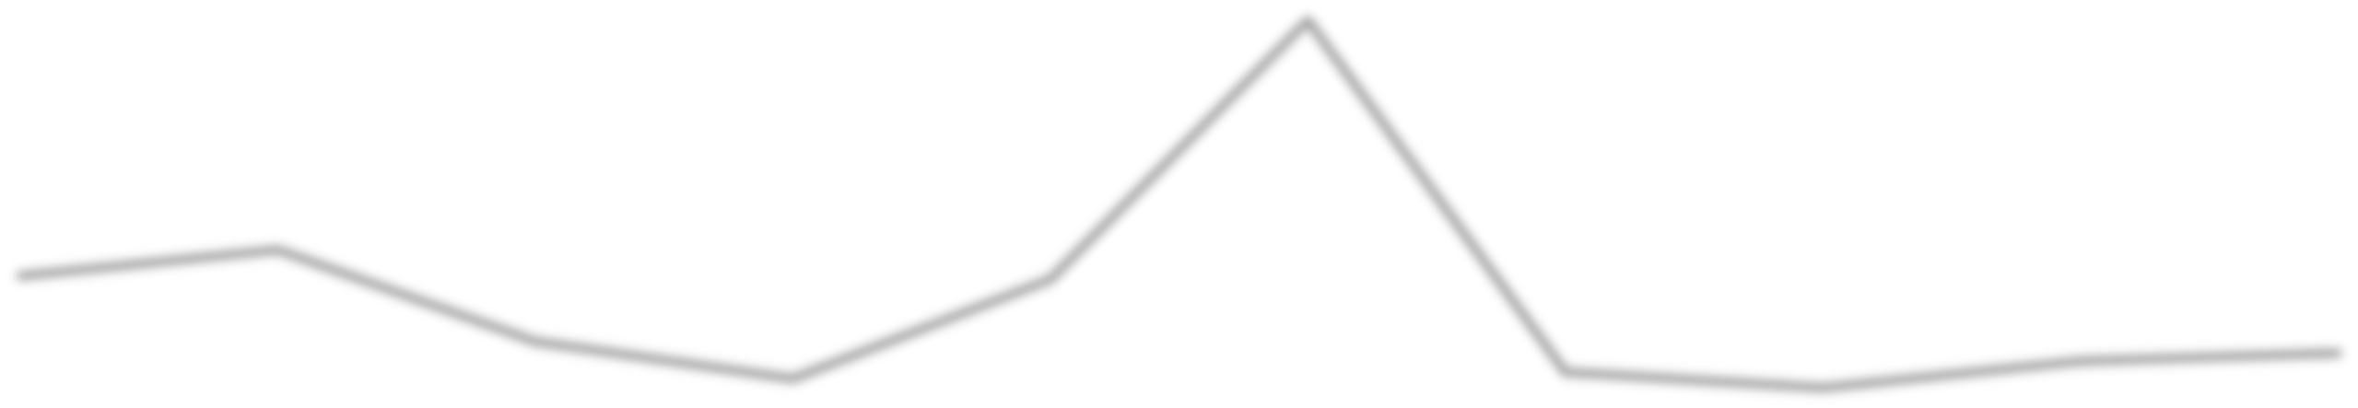
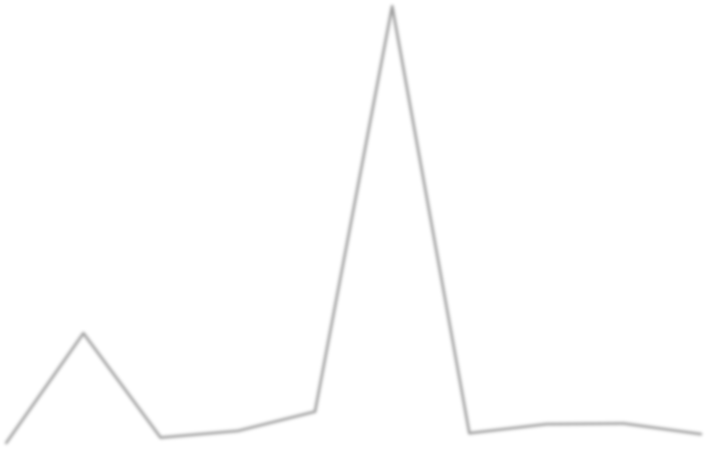
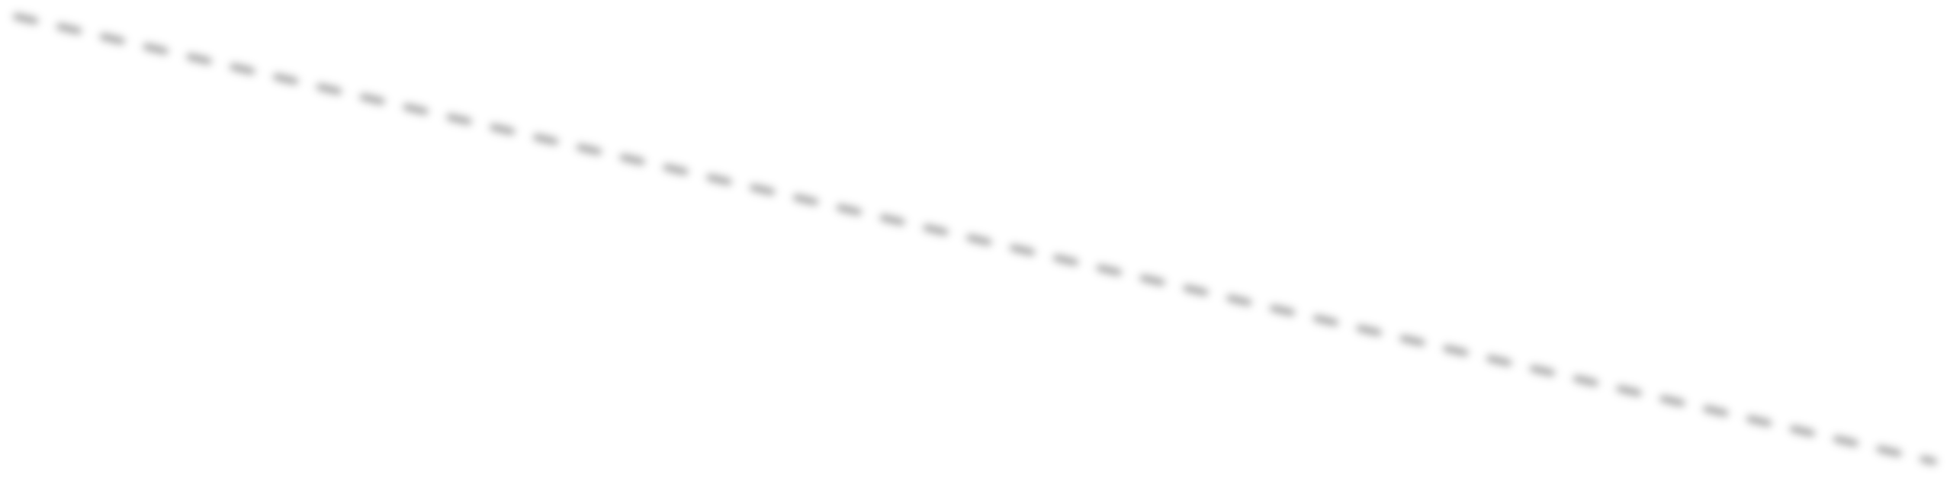






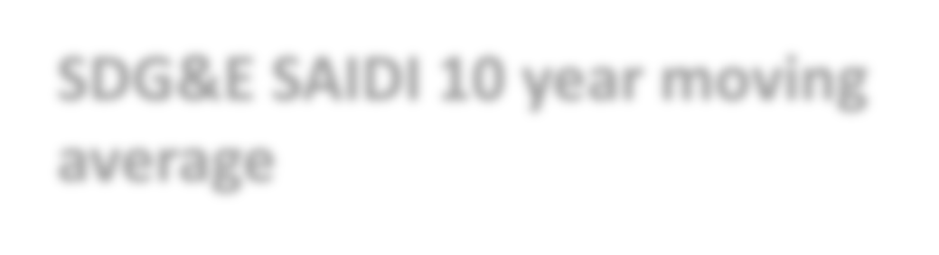




SDG&E
600.00

500.00

400.00

300.00

200.00

100.00

0.00
2006 2007 2008 2009 2010 2011 2012 2013 2014 2015
600

500

400

300

200

100

0
2006 2007 2008 2009 2010 2011 2012 2013 2014 2015

PG&E SAIDI

200.0

SCE SAIDI

100.0

SDG&E SAIDI

0.0
3
2006 2007 2008 2009 2010 2011 2012 2013 2014 2015



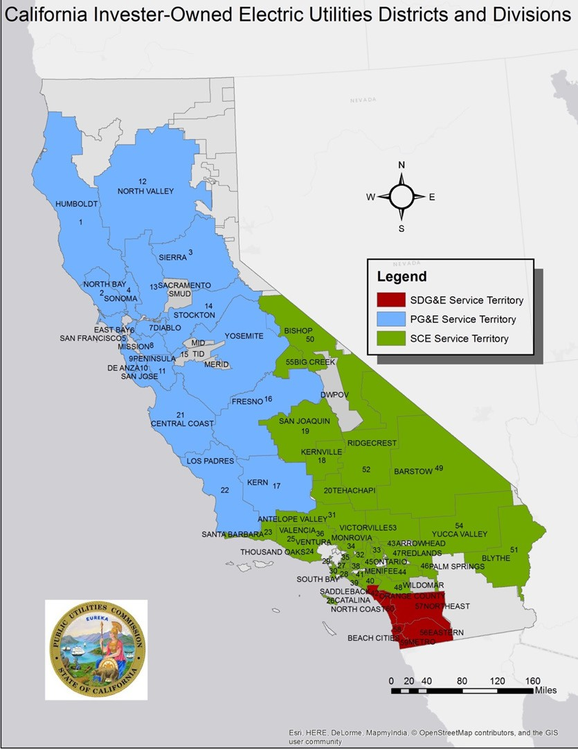
IOU District Map
4

Distribution of District SAIDI Scores

60. Humboldt

59
60

2 57

3 56 58

59. North Valley
58. Blythe
57. Big Creek
56.Yucca Valley


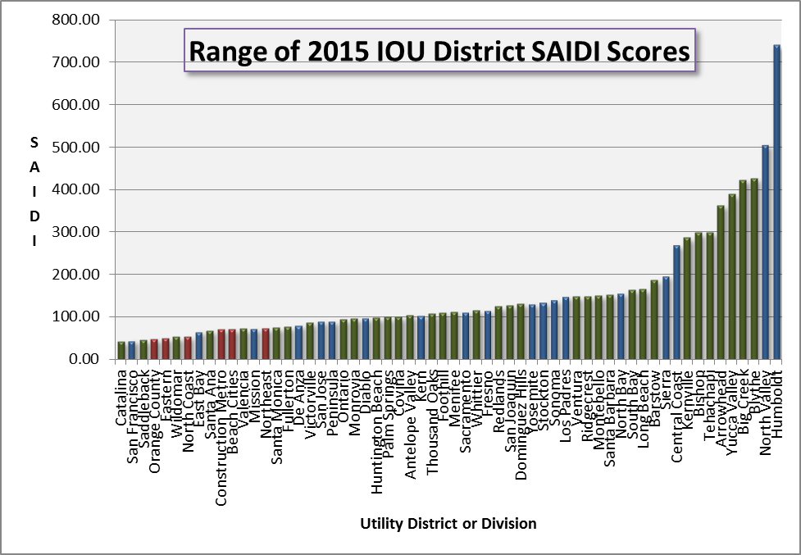
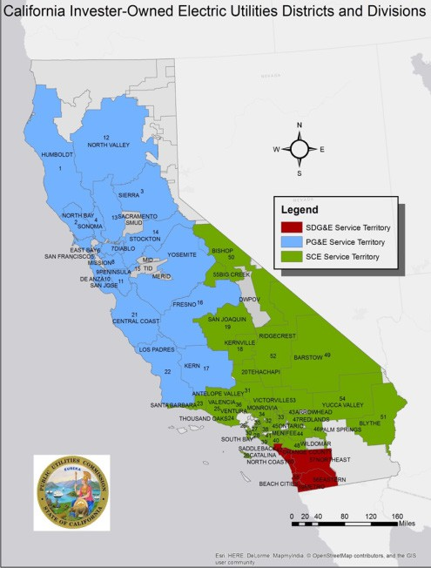




1 4 5
5

PG&E Bay Area - San Francisco Division
SAIDI
45

200
0.544
MAIFI
78
CAIDI
0.575
SAIFI
1.5
200
1.5

150
1.0
150
1.0

100
0.5
100
0.5

50
0 0.0
50
0 0.0



METRICS HISTORY
METRIC
SAIDI
2015
44.7
2014
141.7
% CHANGE
-68%
SAIFI 0.575 0.858 -33%
CAIDI 77.74 165.15 -53%
MAIFI 0.544 0.353 54%


PG&E Northern Region - Humboldt Division

SAIDI
SAIFI
CAIDI
MAIFI
2.839
311
2.382
741
ALL METRICS
1,500
1,000
500
0
4
3
2
1
0
500
400
300
200
100
0
5
4
3
2
1
0

METRIC | 2015 | 2014 | % CHANGE
SAIDI | 741 | 351 | 111%
SAIFI | 2.382 | 1.528 | 56%
CAIDI | 311.13 | 229.38 | 36%
MAIFI | 2.839 | 1.940 | 46%



SCE Orange County - Saddleback District


SAIDI
SAIFI
200
150
100
50
0
1.5
1.0
0.5
0.0
0.39
46
CAIDI
120
200
150
100
50
0

MAIFI
0.379

1.00
0.75
0.50
0.25
0.00
METRICS HISTORY
-54%
99.07
46.03
SAIDI
% CHANGE
2014
2015
METRIC

SAIFI 0.39 0.74 -47%
CAIDI
119.54
133.03
-10%
MAIFI 0.379 0.556 -32%


es County West - Long Beach District
SCE Los Angel

SAIDI


164
MAIFI
1.5
1.0
0.5
0.0
0.89
SAIFI
1.185
CAIDI
184
250
200
150
100
50
0

200 1.00
150 0.75
100 0.50
50 0.25
0 0.00
METRICS HISTORY

SAIFI 0.89 0.61 46%
148%
66.23
164.46
SAIDI
% CHANGE
2014
2015
METRIC
CAIDI
183.90
109.27
68%

MAIFI 1.19 1.168 1%


SCE Los Angeles County West - South Bay District

SAIDI
SAIFI
CAIDI
200
150
100
50
0
2.0
1.5
1.0
0.5
0.0
200
150
100
50
0
126
1.31
164
MAIFI
1.660
3
2
1
0
METRICS HISTORY
31%
125.15
164.07
SAIDI
% CHANGE
2014
2015
METRIC

SAIFI 1.31 1.39 -6%
CAIDI
125.70
90.01
40%
MAIFI 1.66 1.650 1%
10




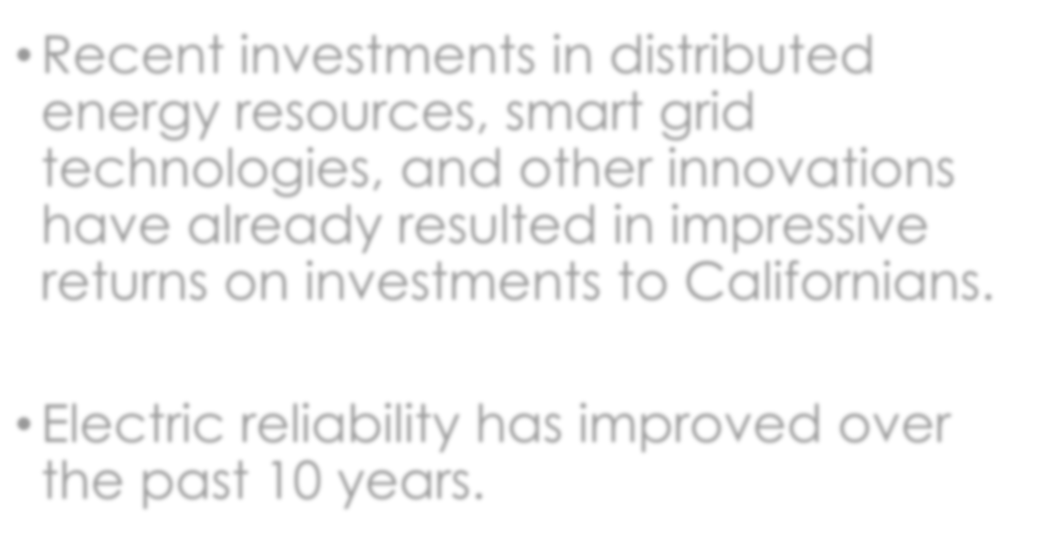
- Recent investments in distributed energy resources, smart grid technologies, and other innovations have already resulted in impressive returns on investments to Californians.
In Conclusion

- Electric reliability has improved over the past 10 years.
11

